Unit 7.2 : Burning
Topic : Putting out a fire
Worksheet 1
Name: ____________________
Class: _________________( )
Date: _____________________

Task 1 : Putting out a fire with candle snuffer
You are given a small candle and a candle snuffer.
Procedure
- Put a coil of copper wire over a candle flame and see what happens.
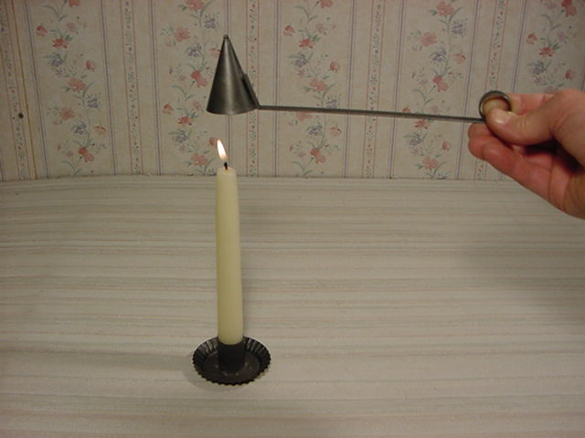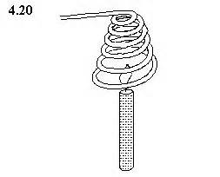
Note: Be careful not to touch the heated coil.
The flame will go out. Sometimes the flame appears to be out but reappears when the coil is lifted

- Explain why the copper coil can put out fire by the concept of Fire Triangle?
The three necessary elements for a fire are ‘fuel’, ‘oxygen’ and ‘heat/temperature’. The copper snuffer is a good thermal conductor. When the copper snuffer is put over the candle flame, it carries away the heat quickly. Thus the fire goes out due to a lack of ‘temperature’.

- Predict what will happen if we lift up the copper wire.
The flame will re-appear.

- Measure and record the extinguished time taken for the flame goes out by putting the copper snuffer over the flame. Repeat the measurement three times and record your observations.
Extinguished time (s)
Measurement 1
Measurement 2
Measurement 3
Average

- Why ‘repeat measurement’ is expected?
Repeat measurement can reduce the errors and increase the reliability of evidence.
Task 2: Boiling water with paper container

Teacher puts water into a paper container and uses Bunsen burner to heat the paper container.

- What do you observe in this experiment?
The paper container is not burnt by the flame and the water is heated up.

- Explain why the paper container does not burn.
The water in the container absorbs the heat and lowers the temperature of paper container.

